Youth Perspective at COP16
COP16 is the Conference of Parties to the United Nations Convention on Biological Diversity – i.e the international convention that tries to protect biodiversity.
I was fortunate to attend this two-week conference, between 21st October and 1st November, in Cali Colombia – one of the most biodiverse countries in the world. I was there to represent both the Global Youth Biodiversity Network* UK (GYBN UK) and Nottingham Trent University, in order to voice youth opinions on the future of biodiversity.
*GYBN is officially recognised by the convention as the youth participation platform, and is allowed to participate in some negotiations, so has good standing to enact changes to policy.
The conference begins with speeches on Colombia’s commitment to nature as well as impressive, and emotional, performances. A moment that will stick with me is the images of forests burning while indigenous peoples sang – I may not understand the language, but the emotions were transboundary.
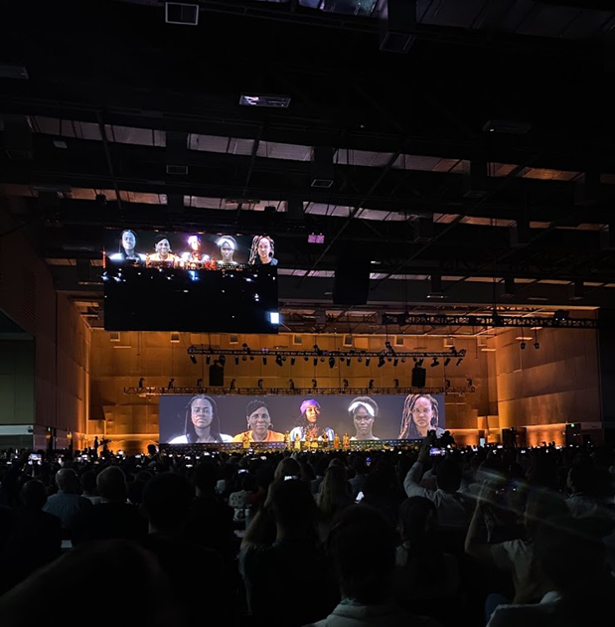
Indigenous Peoples performing at the opening ceremony of COP16
Over the two weeks, there were a whole host of negotiations and side-events taking place each day. Negotiations are split into different groups, that each cover different ‘articles’** in the convention. Observers, like myself, are able to attend these, however some prohibit photos or videos in order to allow countries to speak freely without judgement.
**An article is simply a section or topic of the convention/agreement
Seeing negotiations, as an outsider to policy, was very interesting but at times frustrating. To see countries debating whether the word ‘welcomes’ or ‘acknowledges’ is more suitable, for 35 minutes… They seem to forget the world is losing biodiversity by the second! Though I have been told that these words do matter in international law.
Side events range from panels on different methods of reforestation to group discussions for countries to work together. They can be organised by many different organisations. I spoke on a panel about Nature Positive Universities and how students can be involved, and GYBN UK organised a panel about youth involvement in academia and research! Other GYBN chapters from around the world also held events; to showcase the incredible work they’re doing in their country!

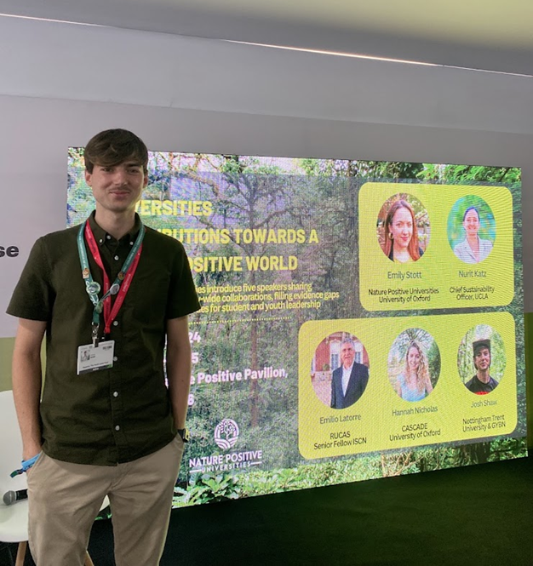
Josh Shaw speaking on a panel for Nature Positive Universities
The chaos of COP slows down, but doesn’t stop, over the weekend. Negotiations pause but side events continue, though we did find some time to get into the cloud forest!
During the second week, ministers and a couple of heads of state from their respective countries attend. The biodiversity COP is a lot less well known than the climate COP, so it was significant to see a few presidents and prime ministers in attendance!
From the UK, Minister Steve Reed OBE Secretary of State for the Environment, Food and Rural Affairs and Minister Mary Creagh CBE Under-Secretary of State (Minister for Nature) were in attendance. Steve Reed provided opening speeches for the UK, proclaiming that “environmentalism is back on the UK’s agenda!”
GYBN UK was able to meet with both ministers briefly, receiving positive messages on our work. We are hoping to work with them further in the future, to ensure UK youth are included in our national biodiversity policy.
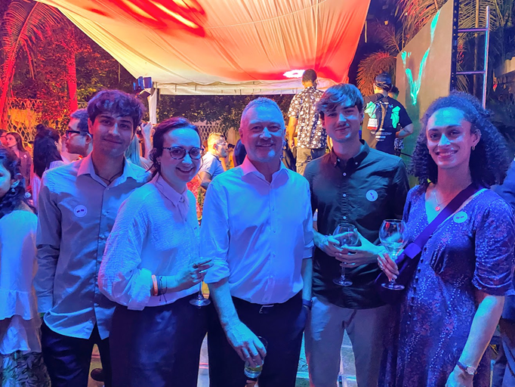
GYBN UK team with Minister Steve Reed OBE
On the final day, the closing plenary (where countries agree to all the text from the two weeks) was scheduled to begin at 3pm. However, due to many disagreements and delays in previous negotiations, it didn’t begin until 10pm on Friday night!
It was expected to be long, continuing until the early hours of the morning, though few could have predicted just how long it took. The night began relatively smoothly, with countries unanimously agreeing to articles, or suggesting minor changes. Some of these agreements were particularly significant. There was a decision on Article 8(j) which gave further recognition to the role of indigenous peoples and local communities in biodiversity protection, and another that identified afro-descendants as another key group! The atmosphere in the room when these were agreed was phenomenal, with chanting and singing! GYBN supported both of these decisions and spoke in the plenary to voice this.
The night continued slowly after this… by 2:30am I called it a night. It was clear progress was slow and they were only half way through the agenda. Two of the GYBN UK team, along with other GYBN members stayed the night, right through till the end at 8:30am on Saturday! 10.5 hours later!
Though COP had not finished… countries couldn’t make it over the final hurdle – finance. Continuing disagreements over the establishment of a new fund for nature could not be overcome and so by 08:30, many countries had to leave to catch flights home. Ultimately, there were not enough countries present to pass any decisions, so COP finished, but never closed.

Overall, there were some significant decisions made at COP16, that will benefit the protection and restoration of nature. Though many question whether this will happen fast enough. It is up to countries to take action themselves, so we must keep ensuring the UK government is doing so. Young people play a significant role in biodiversity protection, but it is not solely up to us, it is a whole government and society effort that will create the most change.
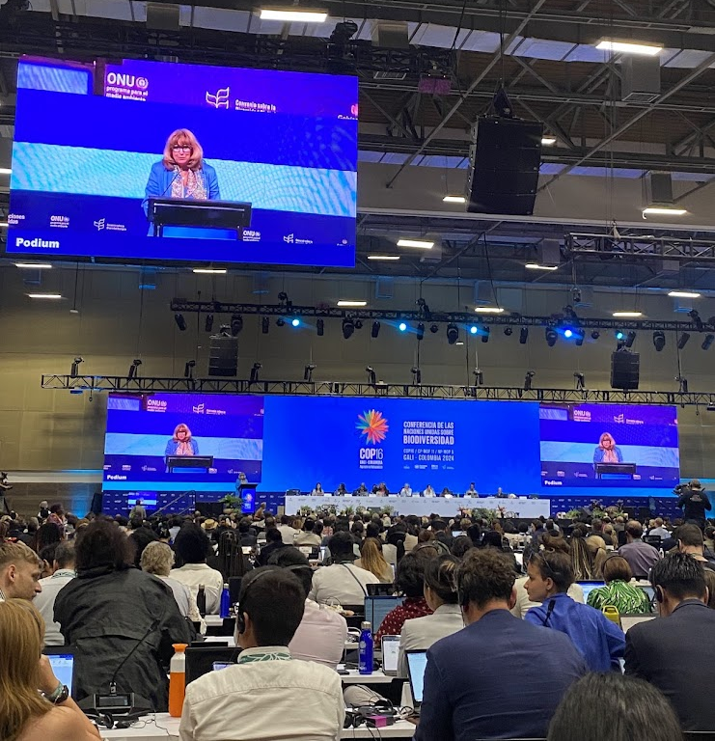
Astrid Schomaker, Executive Secretary of the Convention on Biological Diversity, addressing the final plenary.

